S. R. Shroff Aajivika Trust

2015-16

ANNUAL REPORT



|  |  |  |
| --- | --- | --- |
|  | **About UPL Ltd and its CSR** | 3 |
|  | **SRSAT Overview** | 4 |
| Section 1.0 | **AGRICULTURE DEVELOPMENT- UPL KHEDUTPRAGATI PROGRAMME** | 5 |
| 1.1 | UPL AKRSP SRI Project | 6 |
| 1.2 | Dang Paddy Development Project | 7 |
| 1.3 | Green Fodder Development by Hydroponic method | 8 |
| 1.4 | Agri-technology Project *(*Power Operated Paddy Thresher) | 8 |
| 1.5 | UPL Khedut Niyojaniy Kendra at Vikram Farm | 9 |
| 1.6 | UPL BoriBagicha Project | 10 |
| 1.7 | Dang Moringa Development Programme | 11 |
| 1.8 | KhedutPragati@Ankleshwar | 11 |
| 1.9 | Livestock Health Camp | 13 |
| Section 2 | **EMPLOYABILITY AND ENTREPRENEURSHIP** | 14 |
| 2.1 | UPL Niyojaniy Kendra | 15 |
| 2.2 | UPL Udyamita | 17 |
| 2.3 | Agripreneurship Development Programme | 19 |
| 2.4 | Entrepreneurship Awareness Project | 19 |
| 2.5 | Personality Development Program for ITI students | 20 |
| 2.6 | Skill Based Entrepreneurial Development Program | 20 |
| Section 3 | **NATURE CONSERVATION-UPL VASUDHA** | 22 |
| 3.1 | Eco Clubs | 23 |
| 3.2 | Green Ganesha Workshops | 25 |
| 3.3 | Sarus Conservation Project | 25 |
| Section 4 | Outcome and Success Stories | 27 |
| Section 5 | Way Ahead | 32 |

|  |
| --- |
| CONTENT |

|  |
| --- |
| CSR @ UPL LTD |

UPL Ltd believes in contributing to harmonious and sustainable development of society and that a company's performance must be measured not only by its bottom line but also with respect to the social contributions made by the company while achieving its financial goals.

**CSR Vision:** We and our subsidiaries along with our partners commit ourselves to create a more equitable and inclusive society by supporting processes that will lead to long term sustainable transformation and social integration and by creating opportunities that enable the socially disadvantaged to utilize their potential in achieving their aspirations and ambitions.

**CSR Mission**:

* To implement need based CSR projects and extension work
* To build capacity of community so as to make them self reliant
* To develop partnership with all stakeholders
* To promote and institutionalize CSR with UPL group business strategy

**CSR Values**

* Care
* Excellence
* Partnership
* Sustainability
* Learning and Sharing

***Most of our CSR initiatives are in South Gujarat, Haldia (West Bengal), Jammu (J&K) and Mumbai.***

|  |
| --- |
| SRSAT- An Overview |

S. R. Shroff Aajivika Trust (SRSAT) is a public trust promoted by UPL Limited (formerly known as United Phosphorus Limited) to create sustainable livelihood in community. SRSAT has its Registered Office at 3/11. GIDC, VAPI 396195, Dist Valsad. Gujarat. The SRSAT trust no is E-2718-Valsad and trust registration date is 24.03.2014. The 12AA no. of SRSAT is 841/20/2014-15. SRSAT is exempted U/S 80G of the Income tax Act with effect from 01.05.2014. Sr.No. 152/70/2014-15, Letter No CIT/VLS/Tech./80-G Certi./SSAT/2014-15 Dated 29.10.2014.

The population growth in India is set to make us world’s most populous country by 2025. On one side huge population will require huge livelihood opportunity, on another side parallel expansion of India’s high-growth industries requires a skilled workforce resulting in a fundamental imbalance. In said scenario sustainable livelihood creation holds the key in our ability to activate the vast population for inclusive growth and to create sustainable livelihood. At SRSAT we are well aware of present & future population challenges and believe in helping individuals live a life of dignity. To achieve this, our programmes will focus on generating sustainable livelihoods. The Strategy envisaged for operationalizing the sustainable livelihood will have four pillars.

* Skill Development
* Entrepreneurship Development
* Agriculture Development
* Nature Conservation

|  |
| --- |
| Section 1  UPL Khedut Pragati Program- Agriculture development initiatives |

* 88% of the population in Dang is directly or indirectly dependent on Agriculture and allied activities for their sustenance.
* 66% of the agricultural land is situated on slopes with uneven terrain, which determines the agricultural production pattern.
* Majority of the farmers depend on rain fed irrigation.
* The agriculture production pattern is slowing changing from traditional coarse grains like Ragi, Kharsani and Tuver to Rice.

*Given this scenario, multiple agri projects have been taken up under the umbrella of “UPL Khedut Pragati Program. Most of our agricultural programs are concentrated in Dang because of its high dependency on Agriculture.*

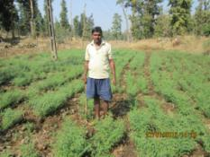

* 1. **UPL AKRSP SRI Project**

***……………………………………………………………………………………………………………………………………………………..***

**Objective:** Paddy provides food security to poor households in Dang district. Even though the state average production of Paddy is 1.86 metric ton per hectare, the productivity in Dang is low (0.6-1.0 metric ton per hectare). The project aims to increase the productivity of Paddy through various interventions.

SRI or System of Rice Intensification is a methodology that utilises all the principles of crop production and brings about improvements in land, capital, water and labor simultaneously.

**Project partner:** Aga Khan Rural Support Programme (AKRSP) is the partner organization for SRI model.

**Project Methodology:**

* Village level meetings and trainings were organized for the farmers on the methodology of SRI. The concept and the process were explained to the farmers.
* The farmers were taken to various SRI plots for understanding the SRI methodology and its practice.
* The process requires using inputs at the right time. The participating farmers were supplied quality seeds and fertilizers at the suitable time.
* To assess the effectiveness of the methodology, we measure the productivity of Paddy in SRI fields as against traditional fields.
* SRI has become a part of the Annual Krishi Mahotsav of Govt. of Gujarat. In the month of May, 17 villages participated in the same. 785farmers benefitted from SRI training and under the mutual experience sharing, 45 male farmers and 90 female farmers got exposure on SRI.
* We also participated in a state level SRI workshop on 23rd May, which was conducted by AKRSP AT Ahmedabad. 3 farmers from our SRI program attended the same and shared their experiences on SRI.

**Program Outcome:**

* The project has reached its 4th year of implementation. At present, there are 1156 farmers across 18 villages who are working on this model.
* Productivity of Paddy in SRI Fields was assessed against traditional fields and our study shows increase in paddy yield by 30% - 50% for different paddy varieties in comparison to conventional method
* It also helped in reducing overall cost of production [seed requirement (from 20kg to 2kg/ acre), 50% less water].

.

* 1. **Dang Paddy Development Project**

................................................................................................................……………………………………………..

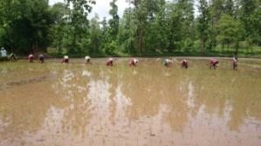High Yield seeds play a vital role in the progress of agriculture. They are considered as miracle seeds which give better quality yield as compared to the traditional seeds. Hence to improve the productivity of Paddy (rice) in Dang district, UPL has taken this initiative to improve paddy production through the use of High yield paddy seeds.

**Objective:** To improve the production of paddy (quantitative and qualitative)by demonstration and availability of high yield paddy seeds. And to build the capacity of farmers through providing trainings and exposure visits.

**Project Methodology:**

* Farmers are taken to see the effect of High yield paddy seeds in various farms. This exposure visit helps them get a firsthand experience of the effect.
* Farmers group of 15-20 farmers per village is formed based on their common interest.
* We arranged training cum exposure visits for farmers at UPL Khedut Niyojaniy Kendra, Vikram Farm - Naholi.
* This project is being implemented in association with Advanta Marketing team.

**Program Outcome:**

* The project has completed 3 years in 2016. It has reached 354 farmers in 10 villages.
* As per our study average increase in Paddy production was 34%, average decrease in labour costs of Paddy was 22% and average decrease in seeds costs of Paddy was 30.5%
* 3 farmers have established hydroponic system with the support of UPL.
  1. **Green Fodder Development by Hydroponic method- New initiative in 2015-16**

**.........................................................................................................................................................**

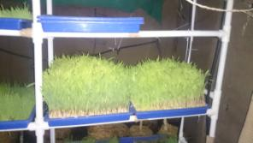Hydroponic grass fodder system is the mechanism of producing highly nutritious green fodder by supplying cereal grains with necessary moisture and nutrients in the absence of soil. The grains are spread onto the specialized growing trays, which are hosted inside the vertical farming method. Trays are watered at pre-determined intervals with four way foggers. This will produce green shoots and root mat within 7 days which can be harvested and fed to livestock.

**Objective:** To develop high nutritional green fodder for dairy animal throughout the year.

**Methodology:**

The CSR team from UPL visited Hydroponic unit at “Abhinav Farmer’s Club, Pune” to understand the concept and the modalities.

We conducted meetings to spread awareness amongst the farmers’ about the technology and its benefits.

We also organized exposure visit for farmers to learn the operation of hydroponic system.

* 1. **Agri-technology Project *–* Promoting the use of Power Operated Paddy Thresher**

**……………………………………………………………………………………………………………………………………………………….**

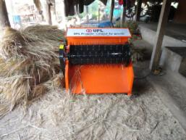Power Operated Paddy Thresher is a low cost machine used for efficient threshing of paddy (removal of grains from the paddy plants) with reduced labour input and grain loss in crop residue. The Thresher operates by one hp electric motor or diesel engine. It separates paddy grains from the straw completely. It also reduces the threshing cost to Rs. 10/- per 100 Kg paddy.

**Objective:** To provide the paddy growing farmers with an efficient system of threshing Paddy and minimize wastage.

**Methodology:**

Farmers groups have been created in each village. These groups become the drivers of all agricultural interventions. These groups are called UPL Pragatisheel Farmers group. On an average there are 10-12 farmers in a group.

Demonstration sessions are organized for explaining the use and benefits of the machine.

The machines are handed over to the groups for operation and maintenance.

**Program Outcome:**

* Threshing capacity of the machine is 300Kg / hour, compared to 35Kg / hour by manual methods. It is much faster and saves time for the farmers.
* We have provided 4 paddy threshers till date.
* 158 farmers from 4 villages have benefited from the program
  1. **UPL Khedut Niyojaniy Kendra at Vikram Farm**

**.........................................................................................................................................................**

The Farmers’ Training School now known as UPL Khedut Niyojaniy Kendra was started in the year 2000 with an aim to provide the farmers a hand on experience on different aspects of farming. **The** Vikram farm is spread over an area of 150 acres in Nahuli.

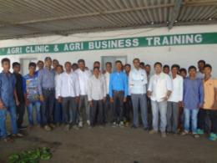**Objective:** To empower the farmers with knowledge and skills needed to increase agricultural productivity. This is done through spreading awareness about modern scientific methods, practical demonstration of crops and farming equipments.

**Methodology:**

* We conduct training programs for the farmers so that they are empowered to adopt sustainable agricultural practices. The training sessions are specific to each period of the agricultural season.
* Practical demonstrations are given on farm site, allowing them to view examples of successful integration of sustainable practices in farming.
* During the training sessions, we give them information about latest farming equipments.

**Program Outcome:**

* 18 trainings were organized in 2015-16, which were attended by 459 farmers
* Since the year 2000 (when this initiative was taken up), more than 12000 farmers have benefited by training and exposure visits at Vikram Farm, Nahuli, Vapi.
  1. **UPL BoriBagicha Project**

**……………………………………………………………………………………………………………………………………………………..**

The BoriBagicha project is popularly known as the backyard or kitchen garden. This project offers great potential for improving household food security and alleviating micronutrient deficiencies.

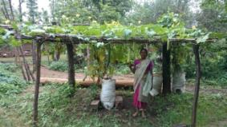

**Objective:** Demonstrate the benefits of Bag Kitchen garden in supplementing nutritional value of tribal homes

To increase and improve the food security of Dang’s inhabitants

Help the farmers to identify and select plants with high nutritional value

Harvests to be planned to coincide with months when the supply of staples is low

**Methodology:** We conduct awareness generation program on the benefits of Kitchen garden which is followed by a theoretical and practical training session with farmers / women. The training sessions are exhaustive and cover the entire gamut of kitchen garden. We focus on the following during our training sessions:

* Nutritional requirements for a healthy living
* Concept of kitchen garden and the material required for the same
* Process of making Bag Kitchen garden
* The various types of support given by UPL Limited to promote the same
* After completion of training, two bags and five types of seed belonging to the *Cucurbita* family are provided to the interested farmers. Cucurbita are good source of vitamin A, vitamin C, potassium, dietary fiber, niacin and folic acid.

**Program Outcome:**

1152 farmers from 10 villages of Ahwa have taken up the initiative.

* 1. **Dang Moringa Development Programme**

**……………………………………………………………………………………………………………………………………………………….**

Moringa (commonly known as Drumstick in English) is a vegetable with the highest nutritional value among many types of food. Its leaves, seeds, seed pods, flowers are a great source of vitamins A, C, iron, potassium, protein and calcium and help tremendously in meeting nutritional needs of a family.

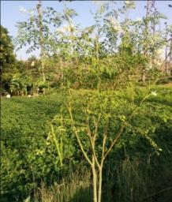**Objective:** To promote Moringa’s plantation as an alternate source of income (through sale of produce)

To attend to food security and malnutrition issues among women & children in the area

**Methodology:**

* In 2014-15, 9 villages were selected on a pilot basis, where more than thirty meetings were organized about Moringa plantation and its benefits. Rohit -1 variety of Drumsticks was promoted through distribution and plantation on farms.
* In 2015-16, many more farmers took up Moringa plantation.

**Program Outcome:**

104 farmers across 9 villages took up Moringa plantation in 2015-16.

* 1. **Khedut Pragati@ Ankleshwar and Jhagadia**

**……………………………………………………………………………………………………………………………………………………….**

**UPL Pragati Sheel Farmers Group** (also known as Farmer Interest Groups) have been formed in Ankleshwar and Jhagadia. All the agricultural interventions are driven through these groups.

* 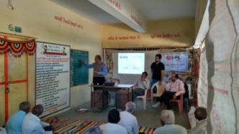12 villages have been covered under the program and 8 groups were formed in 2015-16.
* 117 farmers are now a part of these groups
* 65 meetings were arranged for group strengthening and planning
* 5 Bank Accounts have been opened with a cumulative saving of Rs 28,000.

**Capacity Building programs for farmers**

Various orientation programs were organized for the farmers on Innovative Agriculture practices at multiple locations- KVK, Vikram Farm and more. Topics covered ranged from crop technology to horticulture and more.

Exposure visits were organized for the Pragatisheel farmers.

Trainings were organized for book / record keeping.

Farmers were taken to participate in a Krushi Mela organized by the Government of Gujarat at Surat.

Agripreneurship development programs were organized for the farmers.

**Program Outcome:**

* 21 orientation programs saw participation from 462 farmers
* 10 exposure visits benefitted 240 farmers
* 121 farmers attended the Krushi Mela and 12 benefitted from the Agripreneurship development program.
* 2 trainings on book keeping benefitted 18 farmers.

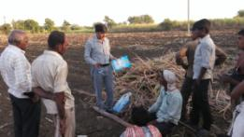

**Lab to Land program:** Under this program, we create demonstration farms where farmers are taken to see the effects of various technological interventions**.** Last year we created 2 such farms – one for sugarcane (spread in 4 acres) and the other for green vegetables (spread in 3 acres).

**Demonstration of Wadi Model**: “Wadi” is a Gujarati word that means small orchard. It is a tree-based farming system that consists of fruit tree suitable to the area or a combination of trees with forestry species. Two or more tree crops are selected in Wadi model to minimise biological and marketing risks.

Under this initiative we took 95 farmers to visit and learn from the wadi demonstration plots.

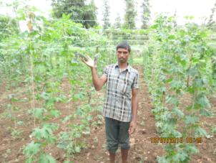**Technology intervention:** We promoted the installation of **Mandap system** for creeper and climber crops. One farmer installed this system in 2 acres of land.

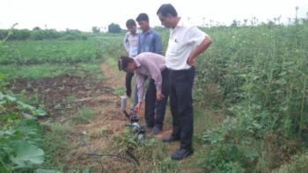**Promoting Micro irrigation**: Micro irrigation is the frequent application of small quantities of water directly above and below the soil surface system. It is a scientific method of irrigation carrying desired water and nutrients direct to the root zone of the plant, drop by drop. The primary advantage of this system is that we get more crops for every drop of water, early maturity, better quality & higher yield. Due to our efforts, 2 farmers have installed this system in their 2 acres plot.

* 1. **Livestock Health Camp:**

…………………………………………………………………………………………………………………………………………………………..

Animal Husbandry or livestock health camps were organized throughout the year for the benefit of the animals and their owners. Our camps see huge participation from the cattle owners, who come to the camps for various reasons.

**Objective:**  To gauge the health status and general well being of the livestock

To find out the common diseases affecting the livestock in the area

Help the owners in increasing production of livestock

**Program Outcome:**

* 5 Animal Husbandry camps were organized, benefitting 1062 animals
* 402 farmers participated and got their animals treated

|  |
| --- |
| 2.0  Employability and Entrepreneurship |

In the year 2014-15, we collected socio economic data of the 5 areas which gave us some meaningful insights. In spite of the fact that so many industries operate in the region, the % of working population is pretty low in the above areas. In Ankleshwar only 27% of the population is working, the figure for Dang is 34%, Halol - 23%, Jhagadia -18% and Vapi – 26%. The population falling in BPL category is also pretty high in Ankleshwar with 75% of the HHs surveyed belonging to the BPL category. In Dang the figure is equally high – 76%.

In this backdrop, it was important to take up initiatives to improve the overall employability potential of youth and women and make them financially independent.

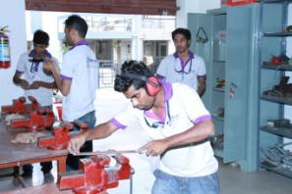

**2.1 UPL Niyojaniy Kendra- *Sustainable, Incremental Livelihoods for underprivileged youth!***

***……………………………………………………………………………………………………………………………………………………….***

“UPL Niyojaniy” (“Niyojaniy” means employable), is a chain of Skill Development Centres, being setup in various industrial clusters, having dominant thematic industrial presence. Current focus areas are Fabrication, Chemical and Electrical sector. UPL Pragati has adopted a two pronged strategy towards Skill Development, one to establish own skill development centres through its Non Profit Organization, S R Shroff Aajivika Trust (SRSAT), at various strategic locations. Second, UPL will offer expertise of building and developing world class organization, to help develop, existing Government ITI institutes, in PPP mode. Since inception emphasis is given on partnership with Government to have multiplier effect to the initiative.

**ITI Partnership in PPP mode:**

Through competitive bidding UPL Pragati won PPP partnership with 2 ITI institutes in Gujarat. Through this initiative UPL will share its technical knowhow and capabilities to build world class organizations. In this partnership new trades would be initiated in ITI institutes, technological innovations such as simulators would be blended with training programs to create better impact of training. Transformational changes would be implemented in ITI institutes through calibrated interventions, in various aspects of operations. UPL Pragati has partnered with ITI Surat (Women) and ITI Amod in Chemical Sector of Bharuch district.

**Skill Development Initiative (SDI):**

SRSAT has set up 4 skill development centres in 3 districts of Gujarat. These centres offer short duration, typically 3-6 months, practical oriented programs aligned to MES pattern of DGET. These programs focus on building competencies and skills of trade. Upon completion of training the candidates undergo third party assessment, by NCVT and successful candidates are offered competency certificates by NCVT. Another 2 centres are being setup in first quarter of FY 16-17.

Over last two years along with new centres, the training capacities are built, as following:

* Makarpura (Vadodara) – 120
* Savli (Vadodara) – 200
* Ankleshwar ( Bharuch) – 280
* Vapi (Valsad) – 200

Over the last couple of years SRSAT has trained more than 350 candidates and offered job placements to more than 200 candidates. Many candidates benefitted by vertical mobility to their careers and few of them ventured into entrepreneurship

**Value chain of SDI**

**Mobilization of candidates** involves meeting lot of communities, group of youths in villages to create awareness about livelihood opportunities in industry. It also needs inspiring youth to take up these skills. In projects with Government partnerships, the candidate selection depends on social status and mobilization becomes all the more difficult with stringent selection criterion.

**Skilling** is all about transfer knowledge, be it practical or theoretical, from Ace Skill men to these youth. All the trainers associated with SRSAT are champions of the respective trade, with years of experience.

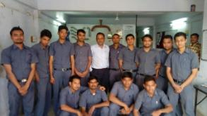

**Assessment of candidates** is carried out on MES guidelines stipulated by DGET. The assessment mainly consists of competency evaluation. It consists of written and practical test. Based on the performance, candidates are awarded competency certificates by NCVT.

**Placement** is the most critical of stage of value chain. The Placement team is assigned the task of searching for job opportunities in respective trade and geographies. The team arranges campus and factory interviews. Candidates are mapped to the companies for jobs at entry level. Handholding is the phase wherein placement team and project associates keep co-coordinating with candidates to ensure they remain in employment. Challenges of candidates at their workplace are addressed.

**Program Outcome:**

* The annual training capacity is 800 participants- Makarpura (120), Savli (200), Ankleshwar (280), Vapi (200)
* Hostel facility is available for outstation participants. The current capacity of the hostel is 65
* In 2015-16, we trained 380 participants out of which 215 have been successfully placed

**2.2 UPL Udyamita**

**........................................................................................................................................................**

“Udyamita” means entrepreneurship. The project has been rightly named as it aims to benefit the rural women through formation and strengthening of Self Help Groups and by promoting entrepreneurship through these groups. This project has been started in partnership with Utkarsh Mahila Association (Valsad) which is an NGO working for the overall development of tribal population in Dang. They have been relentlessly working towards women empowerment through self help groups, vocational trainings, enterprise building and more. The project area is:

1. 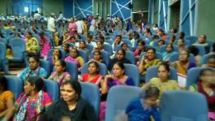Umergam Taluka of Valsad District
2. Pardi Taluka of Valsad District
3. Ankleshwar Taluka of Bharuch District
4. Jhagadia Taluka of Bharuch District

**Objective:** Social and Economic empowerment of women through income generation and financial independence.

**Methodology:**

* Awareness campaigns are carried out periodically to spread knowledge about the concept of Self Help Groups and the role they play in social and economic upliftment of women. The importance of self employment is explained to the rural women and they are motivated to start their journey through joining these groups.
* Self Help Groups have been started and numerous trainings have been organized on various operational aspects like regular maintenance of accounts, nuances of book keeping, dealing with banks etc.
* We conduct audits regularly to monitor progress of these groups and help them when needed.
* We have helped the SHGs to form clusters based on common interest areas and motivated them to take up income generation activities
* Many of our SHGs have successfully started profit making enterprises and are self sustainable.
* Many groups also exhibited their product at Vapi town, on 8th March 2016 during the celebration of International women's day. SHGs from 5 villages also participated in District Vyapar Mela.

|  |
| --- |
| **Program Outcome: Udyamita at Valsad**   * The project has reached 24 villages across 2 blocks (Umergam and Pardi in Valsad) * There are 44 SHG’s at present with 626 members * The cumulative savings of the groups is Rs. 9,07,594/- * 43 trainings were organized for book keeping and 26 for income generation * 24 groups have been linked with banks and other financial agencies * 21 groups have started income generation activities. Some of the income generation activities taken up by the groups are: garment making, jute work, handicrafts, jewellery making etc. |

|  |
| --- |
| **Udyamita at Bharuch**   * The project has reached 9 villages across 2 blocks in Bharuch * There are 33 groups with 386 members * The cumulative savings of the groups is Rs 10,77,390/- * 4 trainings were organized for book keeping * 19 groups have been linked with banks and other financial agencies * 7 groups and 37 individual women members started income generation activities like tailoring , dairy farming etc. |

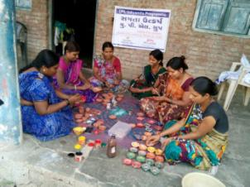

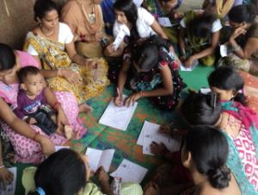

**2.3 Agripreneurship Development Programme**

**........................................................................................................................................................**

A 3 day Agripreneurship development programme was conducted in Vapi (25th September to 27th September 2015), in partnership with **Centre for Entrepreneurship Development** (Govt. of Gujarat). The programme was attended by 25 participants from Ankleshwar and Ahwa.

**The objective of the programme was to:**

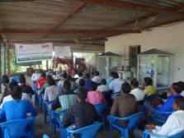To help the farmers explore opportunities in the field of agri business

Promoting an entrepreneurial attitude through encouraging innovation (knowledge, ideas and skills) in the field of agriculture

Help the farmers in preparing an agri business plan

During the programme, case studies on innovative agricultural practices/ businesses were discussed and the participants were taught the finer nuances of making an agri business plan.

**2.4 Entrepreneurship Awareness Project**

**........................................................................................................................................................**

Skill based awareness camps and entrepreneurship awareness camps were organized to promote entrepreneurship and self employment among the youth.

**Objective:** The project aims to spread awareness among the youth about entrepreneurship and the opportunities it offers for gainful employment.

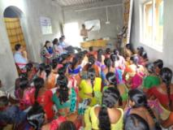**Methodology:** A comprehensive training is organized for the participants which covers the various facets of entrepreneurship. Our training module focuses on the following aspects of entrepreneurship:

* How to identify a business opportunity
* The process of starting a small scale unit
* An understanding of financial aspects
* Calculation of Break Even Analysis
* The power of effective communication skills
* Interpersonal skills and behavioural approach
* How to market your product / service

**2.5 Personality Development Program for ITI students:**

**.........................................................................................................................................................**

Personality development programs were organized for the students of ITI Pardi (District- Valsad).

The objective of the program was to prepare the students for a professional life ahead, make them job ready and equip them with soft skills.

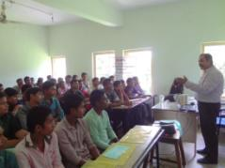Various topics that were covered during the program are:

Communication skills, interview etiquettes, dressing sense, body language, confidence etc.  The students enjoyed the development programs and learnt the finer skills required to work in a professional environment.

**Outcome:**

* 10 skill based awareness camps were organized benefitting 137 participants in district Bharuch
* 3 Entrepreneurship awareness campaigns were organized benefitting 135 participants in district Valsad. 4 such campaigns were organized in Vapi benefitting 161 participants
* 4 personality development programs were organized for ITI students. 135 students from Vapi participated in the same

**2.6 Skill Based Entrepreneurial Development Program**

**........................................................................................................................................................**

This program was conceptualised and implemented to develop the earning potential of unemployed women/youth by providing them integrated skills training. This is a holistic program that incorporates all the components of entrepreneurial development. Our trainings include both technical and life skills aspects.

**Objective:** To equip the trainees with knowledge, skills and confidence to take up entrepreneurship

Promote self-employment and develop the spirit of self-reliance among the unemployed youth

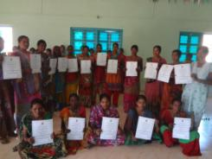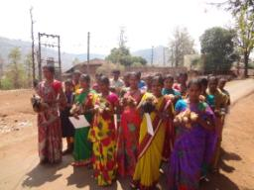

**Methodology:**

* We identify trades based on the need of the area be it farm or non - farm based.
* Professionals/ training institutes are partnered with to provide the trainings.

Details of the training programs conducted in 2015-16 are given below:

|  |  |  |  |  |
| --- | --- | --- | --- | --- |
| Trade | Topics Covered | Duration | Number of Programs | Number of Participants |
| Project Site- Vapi | | | | |
| Stitching & Tailoring | Raw material selection, use of tools, pattern making, designing, etc. | 3 months | 1 | 15 |
| Poultry Rearing | Knowledge of breed selection, production system, flock management practices and cost of production etc. | 2 Day | 6 | 139 |
| Agriculture Inputs | Selection of seeds, chemicals, costing, marketing and packaging | 1 Day | 3 | 61 |
| Project Site- Bharuch | | | | |
| Dairy Farming | Micro lab – Entrepreneurial competencies, dairy farming as a sustainable self-employment venture, artificial insemination, fodder & nutrition , diseases & their control, vaccination, economics of a dairy unit and government schemes | 1 week | 1 | 36 |
| Tailoring | Why self-employment, entrepreneurial competency ,risk taking, making various traditional Indian dresses, marketing, time management, government schemes etc | 1 Month | 1 | 24 |

|  |
| --- |
| 3.0  Environment and Nature Conservation- UPL Vasudha |

Vasudha in Sanskrit means “mother earth”, the giver of all wealth. UPL’s Vasudha program is an integrated nature conservation effort that involves all the stakeholders. UPL has always believed in protecting and promoting a green environment. Most of our programs under Vasudha aim to create public awareness about environment conservation and the need to adopt sustainable actions.

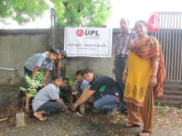

**3.1 Eco Club Project**

**.........................................................................................................................................................**

This is an initiative to make the young generation aware about the importance of protecting nature and maintaining ecological balance. These clubs are formed in schools and students participate in environment related activities through these clubs.

**Objective:** Make the young generation consciousabout the importance of nature preservation and conservation and inculcate good practices.

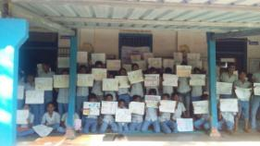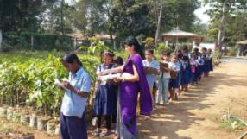

**Methodology:** Schools have been selected in District Valsad and Ankleshwar to take up meaningful environmental activities and projects.

Vasudha clubs have been formed for the students. Students are taken for exposure visit to Vikram Farm.

**Tree Plantation:** Tree plantation is an important activity taken up by the Eco Clubs. Every year, saplings of various plants and trees are distributed to the students/ eco club members. The students along with the UPL team members plant these saplings in various locations. They are encouraged to water the saplings regularly and take care of the plants. Tree guards are also placed at various locations to protect the plants from getting destroyed. Last year we also developed medicinal/ ornamental gardens in schools with the help of students. This brought students closer to nature and improved their understanding of ecology.

We also organized one Training of Trainer program for the Eco Club coordinators in association with the GEER Foundation. 76 Eco club coordinators attended and benefitted from the training.

5 programmes were organized for exposing children and youth to solid waste management principles. 450 children and youth participated in these programs which were organized in Vapi.

|  |
| --- |
| **Project Vasudha in District Valsad:**   * 30 Eco Clubs functioning in schools * 1210 sapling provided to school children across 6 schools * 34 exposure visits organized to Vikram farm benefitting 783 students * One medicinal garden and three ornamental gardens developed in schools * Drawing, elocution and other competitions organized in 10 schools and 1229 students participated |

|  |
| --- |
| **Project Vasudha in District Bharuch:**   * 11 Eco Clubs are functioning in schools * 5540 plants were distributed to 1774 Students across 13 Schools. (Neem, Gumahor, Kashid, Paltro, Asopalav etc. And horticulture plants like Guavas, Badam, Amla etc) * One exposure visit cum environment education Shibir was organized which was attended by 52 students and 8 teachers. * Environment day was celebrated in 12 schools and various activities were organized like essay, writing, drawing competition, elocution and more. * 40 tree guards were provided to the Panchayat and temple. |

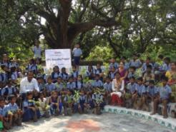

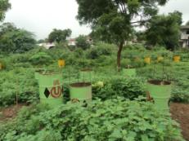

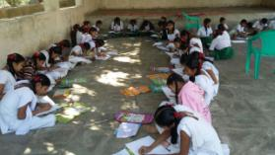

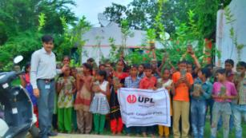

**3.2 Green Ganesha Workshop:**

**....................................................................................................................................................................**

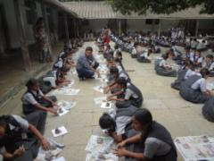The importance of having a viable environmental friendly alternative to the current Ganesha idols produced from Plaster of Paris has now become imperative. This year, UPL in collaboration with Parisar Asha helped bolster this eco-initiative by organizing Green Ganesha Workshops in schools. This sustainable substitute is colloquially known as Shadu Mitti or river clay and was traditionally used to create Ganesha idols. The workshops helped to reinstate the lost art of making Ganesha statues with Shadu Mitti back into society and create awareness for environment.

The workshops were organized in 10 schools of Mumbai and 4 in Vapi, Gujarat. The workshops saw a huge participation of 1470 students.

**3.3 Sarus Conservation Project, Vadodara**

**......................................................................................................................................................**

**Rationale:** There are 15 species of cranes found in the world today. Out of the 6 that are found in India, only Sarus Crane (Grus antigone) is a resident species. The Sarus Crane is nearly six feet tall with a wings pan of eight feet and it is the world’s tallest flying bird. These are known to use wetlands and agriculture fields and live in association with human beings. In Gujarat, they are found in Ahmedabad, Anand, Baroda and Kheda districts.

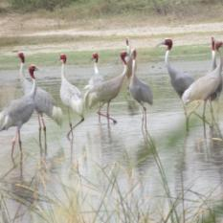

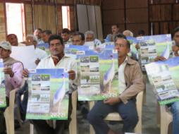

**Objective:** The Sarus conservation project was started last year with the following objectives:

To assess the status of Sarus crane’s presence in selected districts of Gujarat

To understand their preferred habitat

To gauge the threats to these birds and the awareness of local communities w.r.t to the bird

Based on the above assessment, we planned to design conservation steps and carry out awareness programs.

**Methodology:** Our study sighted fifty seven pairs of Sarus cranes and fifteen single Sarus cranes in the area. Sixteen nests were recorded in different sites in Kheda and Vadodara district.

To create awareness among school student’s different programmes were organized. Twenty two awareness programmes were held in which 1658 students and 71 teachers participated. They were imparted information on Sarus cranes, its habitat and importance through documentary in Gujarati. Posters, pamphlets, slide shows, lectures and poster, presentation talks were organized in the crane breeding areas. Drawing competition, spot quizzes, movie screenings were also done to spread awareness amongst the students.

An awareness programme was also conducted with the forest department at the Pariej wetland. The programme was conducted for 4 schools where 283 students and 13 teachers participated.

**Community meetings**: Six community meetings were held with participation of 181 community members and farmers.

**Rural Sarus Protection groups**: One training workshop was held for the Rural Sarus protection group where 35 farmers and volunteers participated.

**Banners at breeding sites**: 5 banners were installed at different breeding sites of Sarus Cranes in Kheda district.

**Posters and pamphlets for awareness programmes**: 1000 posters and 4000 leaflets were prepared in local language and Hindi for distribution during awareness programmes. The handouts include information on Sarus cranes breeding cycle, their role in agriculture, threats to the species and conservation measures to be taken for the survival and protection of species.

**Distribution of Sarus Cranes and Breeding Information**: Regular survey was undertaken in all the tehsils of Kheda and Vadodara. Distribution of Sarus crane was recorded July onwards (which is also the breeding period of the cranes) and nesting sites were documented. The farmers were contacted and made aware of the nest and motivated to protect nests from being predated or destroyed. Regular meetings were organized in the village clusters and in schools to ensure protection of nests.

Thirty four wetlands in Kheda and Vadodara district were documented during the surveys. Total 250 Sarus Cranes were recorded during summer survey and 140 during winters at Chanor, Limbasi, Vastana and Bhalada.

Major congregation sites of Sarus cranes were Gobarpura, Narda, Hobal and Heeranj during summer. Breeding in 13 (hatching success in 11 nests) nests were observed with 44 juveniles surviving. Total 468 Sarus cranes were counted in Kheda district.

|  |
| --- |
| 4.0  Performance |

* 1. **Some snapshots of project outcomes in 2015-16.**

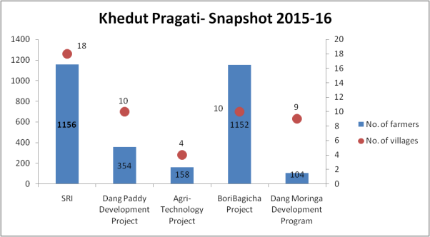

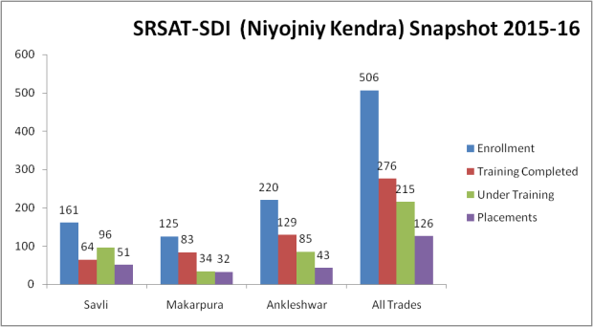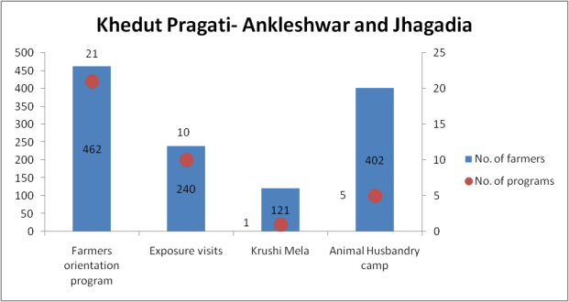

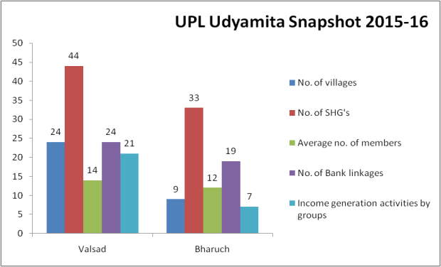

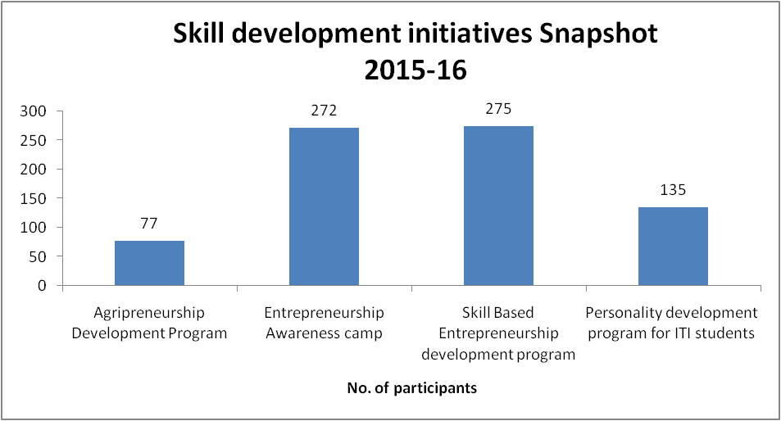

* 1. **Success Stories**

Some project outcomes are measurable in terms of figures and statistics while many are in the form of social and cultural changes, which are immeasurable. They can only be felt and experienced. We are happy to share some stories of grit and determination that brought about immense measurable and immeasurable impacts on the lives of people.

**From Udyamita**: **The story of Sumitraben.**

Sumitraben is the proud owner of a tea and snacks stall in Vapi. She is a member of the Adarsh UPL Utkarsh SHG (Pardi). She opened the stall in October 2015 and has been running it single-handedly since then. Sumitraben got the confidence and the courage to start her own business after becoming a member of the group. She learnt business skills and took a loan of Rs 20,000 from the group and started her business. Today she earns Rs 500-1000 per day from her stall. Her eagerness to work and the zeal to stand on her own foot and earn has brought her success.

**The story of Geetaben.**

Geetaben is a member of the Adarsh Utkarsh UPL Group (SHG), who started her own enterprise of making Agarbattis. Though Geetaben has always been a working woman (She earlier worked as a financial advisor and insurance agent), she never had the courage to start up an enterprise on her own. After becoming a member of the SHG and receiving training on entrepreneurship, she got the skills and the confidence to take up entrepreneurship. Geetaben took a loan and set up 2 manufacturing machines. She does manufacturing and sales all by herself. Her zeal and enthusiasm is reaping rewards and she has been able to make profits from her business.

**Growing together – The story of Hari Om Mahila Bachat Group, Fulwadi.**

Hari Om Mahila Bachat Group was formed on 12.06.2012 with the initiative of 14 village women and the block development officials of Fulwadi Panchayat Union. Currently the group has a savings amount of Rs.48, 890. The group has been very regular with their monthly savings of Rs 100 and meetings. They realized that to grow economically, they needed to start some income generating activity. The group mutually decided that they would want to start a tailoring unit in the village. They approached the UPL officials for guidance. The block development and UPL officials forwarded a proposal for Economic Assistance under mission “Mangalam Yojana” for tailoring. The bank (Bank of Baroda, Jhagadia) provided a loan of Rs One Lakh to the group. The District Industries Centre also provided a 35% subsidy to the group. The group utilized this amount to buy tailoring machines and raw materials. This strengthened their existing skills and resource base and now all the members are involved in this trade on a full time basis. At present, each member is earning Rs 1000 every month from the tailoring work. This initiative is slowly transforming a socially and economically backward village into a progressive village on the path of development.

**From agricultural interventions:** **The story of Meeraben**.

Meeraben lives in Dabdar village with her husband and 3 children. Meeraben is a member of the SHG formed in the village. During one of the meetings, she was introduced to the concept of landless garden for vegetables. She showed interest in the methodology and got support from the team. She practiced the concept and has been reaping benefits since then. Her family’s requirement of green vegetables is met from her own garden and this has drastically reduced her expenses on buying vegetables. Not only this, she gets fresh produce which has improved the nutritional value of her meals too. Looking at her experience, many of her neighbours have adopted the system too.

**The story of Mohan Bhai.**

Mohan Bhai is a farmer from Davdahad village in Dangs district. He has a family of 7 who are entirely dependent on agriculture for their sustenance. Like a majority of farmers in Dang, Mohan Bhai also grows Nagli, Paddy, Varai and Pulses in the traditional method. Under SRI, a lot of awareness generation activities were conducted in his village. He saw the different steps like bed preparation, transplanting the seedling at a tiny age, one seedling per hill transplanting, and use of cono weeder. After much persuasion from the team, he agreed to do line planting in 0.25 acres of land. He also did spacing in the prescribed distance and used cono weeder. Within 15-20 days of planting, he could see the difference in results from earlier method. He is very happy that he listened to the advice from the team and applied the SRI methodology.

**The story of Balu Bhai Patel.**

Balu Bhai is a progressive farmer from Kasia village in Ankleshwar. He is a part of Suryoday UPL farmer group which was formed in 2015-16 with the initiative of 16 farmers. The group submitted a proposal for economic assistance under Mission Micro Irrigation with the help of block development officials and UPL officials. The proposal was approved and the Govt, Of Gujarat granted a 60% subsidy to the group. UPL CSR team also provided Rs 15,000 to the group. The group bought a Drip Irrigation System, with the help of this grant. They also attended a 7 day training program in Vikarm Farm, Vapi. Today Balu Bhai uses the Drip Irrigation system to grow vegetables in his farm. This has increased his monthly income from Rs 3000 to Rs 6000.

In the words of Balu Bhai “Irrigation alone improves yield by 60 to 100 % and is a real aid to enhance vegetable output. Drip irrigation goes even further. The water saved by drip irrigating vegetables - as much as 40 per cent of current usage can be used to irrigate a larger area.”

**From Entrepreneurship Development: The story of Narendra Vasava**

This is the story of Narendra Vasava who is currently working in UPL Jhagadia as a plant operator. Narendra joined SRSAT Ankleshwar and successfully completed his training. Narendra says that the trainers and the staff were very supportive and understanding. He not only got skilled in technical field but also got an opportunity to groom himself as a professional. Coming from a humble background (where his parents work on farm) Narendra had not imagined a better future than this.

|  |
| --- |
| 5.0 Way forward |

2015-16 was rewarding in many ways. We plan to make 2016-17 even more challenging, exciting and fulfilling. Though the thematic focus will remain the same, many new initiatives will see light of the day within the thematic focus.

In agriculture interventions, we plan to take SRI to new crops apart from Paddy. Traditional crops will be brought in the gambit of SRI methodology and we target to take SRI to around 2000 farmers by the end of next year. Similarly Dang Paddy Development Project will receive more focus to ensure agriculture becomes a viable livelihood option for the farmers of Dang. We will also be targeting to increase the nutritional value of the produce through our interventions. Capacity building will see more rigour and technology will be used extensively in agri interventions. The objective is to ensure a quantum increase in the income of farmers in the area.

Working on employment and entrepreneurship development has always been a passion for us. Niyojaniy Kendra will receive new thrust in 2016-17. We will work on increasing the capacity of the Kendra to around 1000 students per year. We are also working at providing many new additional programs to the students for their overall development.

We have been conducting entrepreneurship awareness camps with great enthusiasm throughout the year. The same will help us in launching new entrepreneurship programs in future as the groundwork has already been prepared.

In Vasudha, we have planned a lot of activities for the preservation of Sarus Cranes. We will focus on taking the program ahead with the help of all the stakeholders.

We look forward to a rewarding 2016-17 ahead!